The U. S. Election Industry

Abstract
This paper identifies some metrics of concern for US citizens against a backdrop of political parties in control. Political campaigns use similar metrics to influence elections.
In this paper, a party is in control of the federal government when it controls two out of three of these entities:
- Presidency
- Senate
- House of Representatives
Each metric has many drivers but detailed analysis of these drivers is beyond the scope of this paper.
This paper does not try to portray the USA in decline or ascendency but examines measurable changes against the alternations of party in power.
This paper suggests generative politics, a system that can be used to analyze and synthesize political propositions.

Debt to GDP
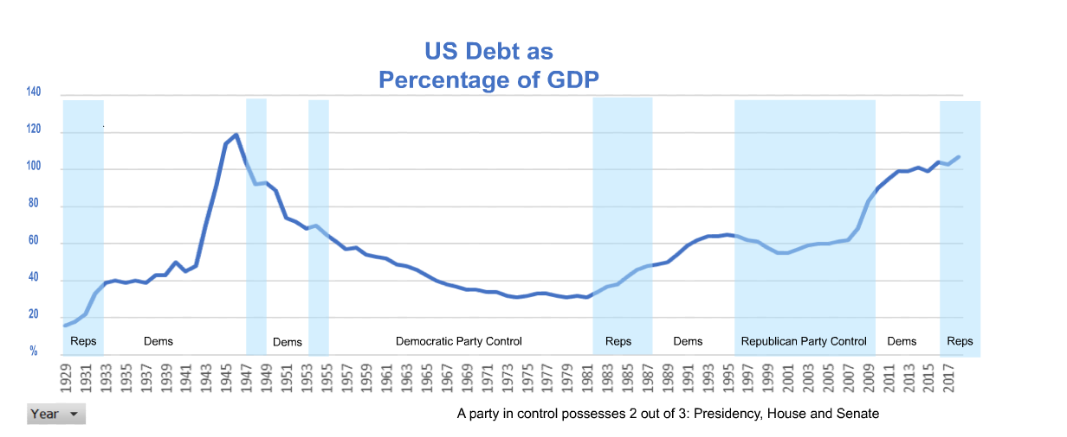
Financial data is from the Bureau of Economic Analysis, Federal Reserve.
The debt depicted is the debt borrowed by the Federal government, assumed by American individual and corporate taxpayers. It does not include corporate or household debt.
Some features:
- Borrowing increased to 120% of GDP by 1945, presumably to pay for the War.
- The debt was paid down to 30% by 1981.
- The debt has unsteadily increased to about 100% of GDP since 1981.
- The rising and falling occurred irrespective of party in control.
High debt-to-GDP is the norm for countries worldwide as borrowing is viewed as a stimulus for national economies.
This paper uses the USA debt-to-GDP as a historical backdrop to the other metrics.

Traffic Deaths
Traffic deaths per million miles exhibited a steady decline from 1929 to 2016, irrespective of party in power, presumably caused by increased freeway driving, safer cars and better enforcement of traffic laws.
This chart shows that metrics can be improved by concerted action.
Source: Wikipedia https://en.wikipedia.org/w/index.php?title=Motor_vehicle_fatality_rate_in_U.S._by_year

GINI Index of Inequality
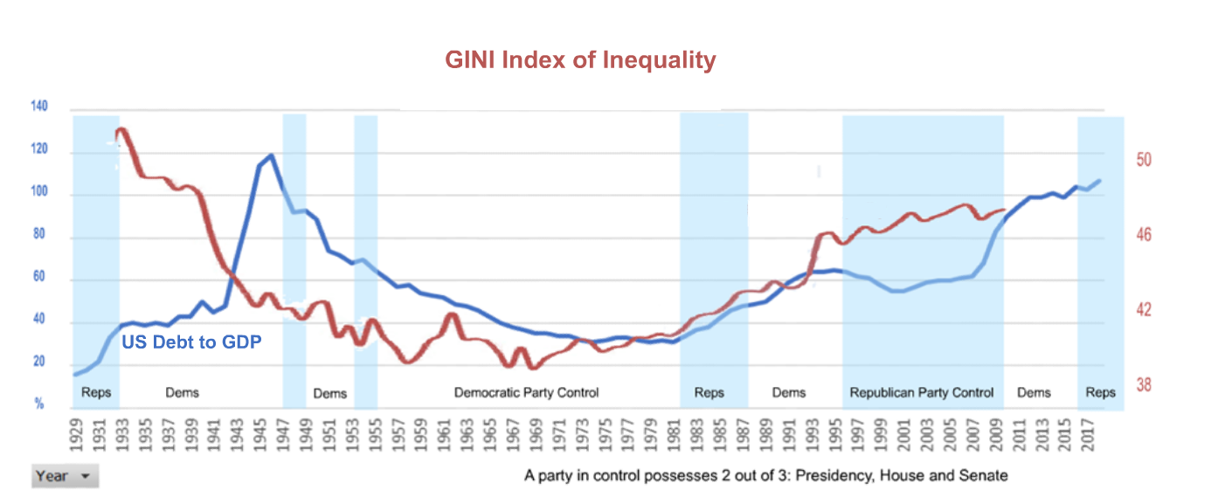
The GINI index measures the inequality of a nation. The index is high when wealth is concentrated in the few and low when wealth is distributed over the populace.
The U. S. became more equal following the Great Depression, falling unsteadily to a low of about 39 in 1969 before rising unsteadily to almost 48 in 2010.
The rising and falling of the index occurred across alternating periods of party control.
Globally, nations vary from about 20 (highly equal) to about 65 (highly unequal).
Source: http://www.the-crises.com/income-inequality-in-the-us-1/

Income Levels
The Income Levels chart tracks the average of the lowest three-fifths of income earners in green and the sum of the highest two-fifths of earners in orange.
The 2 levels were about $20,000 in 1969 and diverged to a difference of about $265,000 by 2017.
The lowest quintile of wage earners showed no increase in income between 1969 and 2017.
The data is consistent with the GINI chart, which shows an increase of inequality beginning about 1969.
Source: https://www.census.gov/data/tables/time-series/demo/income-poverty/historical-income-households.html

Suicide Rate
Suicides reached an all-time high of 22 per 100,000 in the United States in 1931, declined to about 11 in 1945, remained unsteadily low until 1999 and then steadily increased to 14 by 2017.
The rate might be driven by recessions, with the Great Depression exhibiting the highest rates of all.
The rate was unsteadily flat through many administrations from 1945 to 1999 and rose steadily from 1999 to 2017, a period that saw a large decrease in manufacturing jobs, a decrease in middle-class earnings, a rise in economic inequality and 2 recessions.
Source: https://www.newscientist.com/article/2207007-us-suicide-rate-at-its-highest-since-the-end-of-the-second-world-war/

Decline in Manufacturing
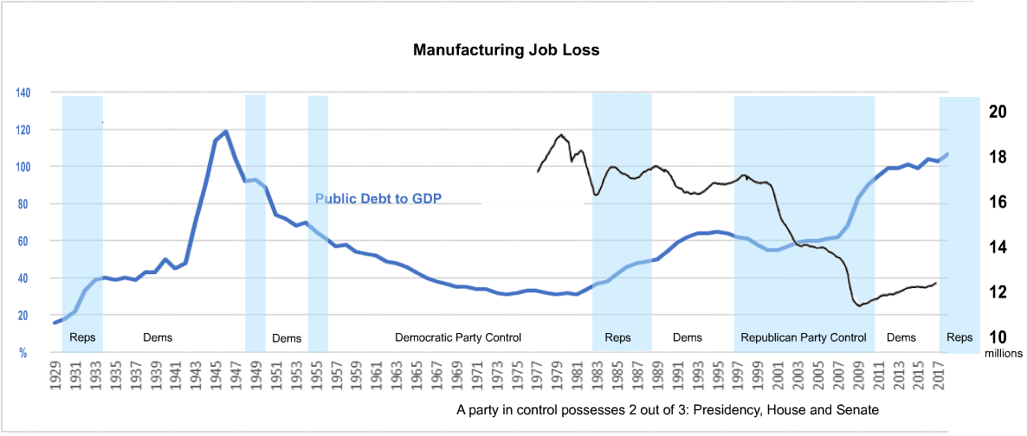

The US had a decline in labor employed in manufacturing from a high of about 19 million in 1979 to a low of 11.5 million in 2010, despite increases in population. Steep declines occurred in 2002 and again in 2009, coincident with the Dot Com and Subprime recessions, with some recovery in 2012 through 2017.
The source-authors note that import of manufactured goods, especially from China, is responsible for about 25% of the decline in US manufacturing employment. Productivity improvements, such as automation, are responsible for 75% of the decline. For those who continued to work in manufacturing, the decline was accompanied by reductions in wages and benefits.
Manufacturing tends to be localized resulting in some regions being hit much harder than others. The decline is also more prevalent in the less educated workforce, for which the economy previously provided long-term careers making it possible, to buy homes and send their children to college. The decline affected men more than women.
The authors associate the general decline with increased opiate use and declining health.
The decline continued unsteadily through periods of Democratic and Republican control.
Source: National Bureau of Economic Research https://www.nber.org/papers/w24468.pdf

Unemployment
The chart depicts the percentage of the workforce collecting unemployment insurance benefits against party control of the Federal government.
The numbers appear to follow business cycles. For example, peaks in unemployment occurred during the Great Recession in 2008 and less obviously during the Dot Com bubble.
The figures do not include workers who have dropped out of the workforce, who work in the informal economy or who are self-employed.
Source: Federal Reserve Economic Data https://fred.stlouisfed.org

Union Density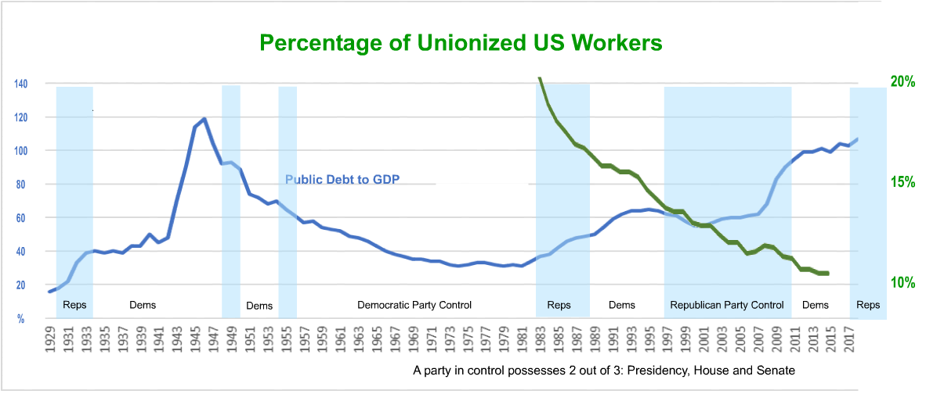

Union Density source: https://www.bls.gov/spotlight/2016/union-membership-in-the-united-states/#:~:text=Union%20membership%2C%201983%E2%80%942015%20%20%20%20Year%20,%20%2096%2C903%2C000%20%2029%20more%20rows%20
Corporations try to minimize costs.

Adoption of Right to Work laws was intense in the decade after WWII and again in the decade 2011 to 2016.
Corporations employ professional consultants specializing in defeating worker-elections of unions.
Right to Work Source:
https://worldpopulationreview.com/state-rankings/right-to-work-states

Ocean Temperature
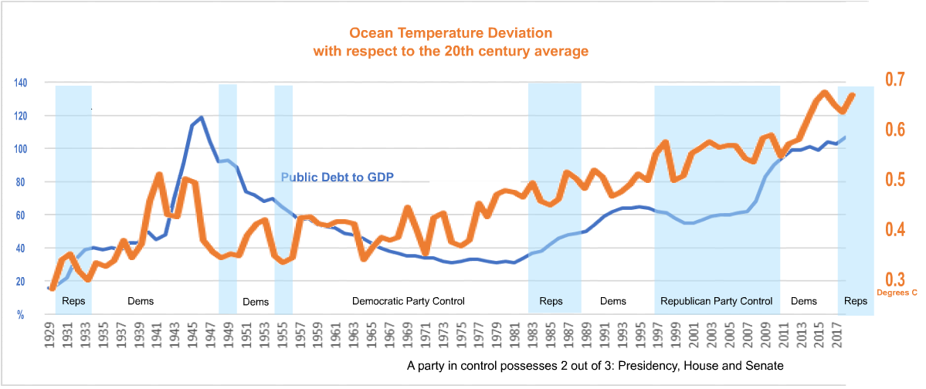
Ocean temperature is an indicator of climate change as it responds more slowly than atmospheric temperature, which can vary wildly from year to year. Ocean temperature has risen unsteadily since 1929, with high readings during WW2 and the highest readings being the most recent.
Climate began to change in 1870 in response to increased industrialization using fossil fuels to run the machines.
Source: National Oceanic and Atmospheric Association, National Centers for Environmental information https://www.ncdc.noaa.gov/cag/global/time-series/globe/ocean/ytd/12/1880-2019

Murder Rate
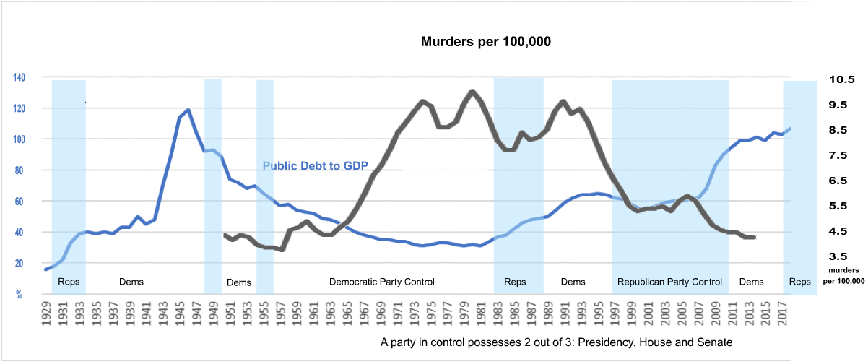
This chart shows murders per 100,000 for the US.
Source: FBI Uniform Crime Reporting Statistics http://www.ucrdatatool.gov/

Military Spending
Macrotrends: “[E]xpenditures include military and civil personnel, including retirement pensions of military personnel and social services for personnel; operation and maintenance; procurement; military research and development; and military aid (in the military expenditures of the donor country).”
While declining from 9% to 3% of GDP, military spending oscillates with a period of 20 years.
The trend in declining military expenditures vs GDP continued under both parties since 1960.
Source: World Bank via https://www.macrotrends.net/countries/USA/united-states/military-spending-defense-budget. Retrieved 2021-01-03.

The Industry
An industry is an economic activity concerned with the processing of raw materials and manufacture of goods in factories. In modeling the election industry, the raw materials are the opinions of voters, as measured by polling and elections. The factories where the opinions of voters are manufactured are advertising campaigns, news programs, word-of-mouth and political parties. The manufactured goods are the influenced opinions of voters with respect to issues and candidates. The economic activities include campaign financing and control of the domestic and international economies.
The national economy, measured by GDP, is about $20 trillion annually. Global GDP is over $80 trillion in 2020. (https://www.statista.com/statistics/268750/global-gross-domestic-product-gdp/#:~:text=In%202020%2C%20global%20GDP%20amounted%20to%20about%2084.54,services%20produced%20in%20a%20country%2C%20often%20measured%20annually)
In 2020, the top ten presidential candidates raised $2.3 billion for their campaigns. Biden raised more than Trump. Of the 8 candidates out of the big money, Harris raised the most from big donors, more than the total from big donors raised by Sanders and Warren. Biden and Trump raised about one-third of their money from big donors.
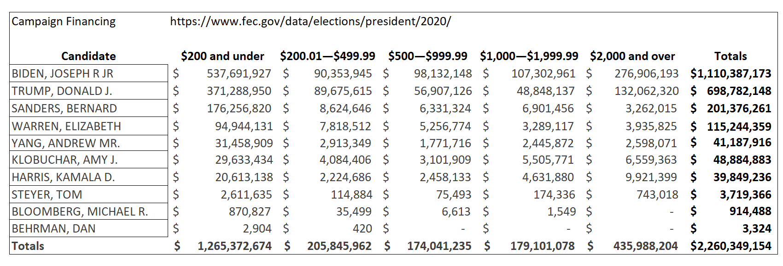
The US House of Representatives spent $815,947,941 on their 2016 campaigns. The US Senate spent $554,571,492 in their 2016 campaigns. Using the 2016 numbers for the House and Senate and the 2020 numbers for the presidency, advertising campaigns spent $3.6 billion dollars on recent general elections for leverage of the national and international economies.

A Speculation
Issues exposed by the above metrics include the decline of manufacturing jobs, the growth of inequality and increasing ocean temperatures. The result is a class of Americans who are sinking economically, joining the underclasses of African-Americans, American Indians and Latin Americans, all suffering the effects of income loss, droughts, storms and rising sea levels.
The American people are unable to change the status quo because we are factionalized into groups that bitterly oppose each other, hiding the elites who make and execute law.
The administration and campaigns of Donald Trump did nothing new in this respect but amplified existing divisions. He increased the animosity between voters in the two parties as evidenced in the unusually large voter turnout as they rushed to support one party over another. He created divisions within the Democrats as they rushed to defend John McCain, a foreign policy hawk, against Trump’s criticism. Trump assaulted the New York Times and the FBI, traditional defenders of wealth and privilege, prompting liberals to rally to their support.
He increased the hatred between poor whites, poor blacks and poor immigrants. Poor whites have always been encouraged to hate and abuse poor blacks, even though both groups are exploited by the wealthy elite. A persistent nightmare of the 1% is the unification of the poor. The new underclass is joining the older underclasses, which they have been trained to hate.
Trump benefitted the middle-class owners of real estate and stocks, which increased in value throughout his administration. The college-educated knowledge-workers disdained the declining white lower class while pretending to support the black underclass.
The decline of manufacturing jobs adds to a new underclass that hates the college-educated elite and their institutions such as newspapers, universities and technical businesses.
Trump supported the police, seen as the protectors of superiority by white Americans and as an occupying army by black Americans, deepening the division.
Trump promoted the hatred of socialism, which seeks to minimize political and economic differences. Thus, Trump pitted the victims of the structure against its saviors.
Trump promoted hatred of other nations such as Iran, North Korea, Russia, China and Cuba, justifying a large military budget, perpetuating external animosities and starving efforts to ameliorate strife within the target nation. War creates nationalists, who typically carry their primitive, hate-driven nationalism with them their entire lives. Trump’s sanctions on these countries impoverished their lower classes, punishing them for their government’s actions.
He continued support for repressive regimes in Latin America, Africa and the Middle East, deepening the animosity with their impoverished lower classes and inspiring revolution, migration, xenophobia, anti-immigrant legislation and hatred for Washington DC. Police lynching of black Americans is only the tip of the oppression of black Americans, which is only the tip of American oppression of underclasses worldwide.
The pandemic provided him with a new opportunity at division as deniers pitted themselves against public health advocates. Thus, the structure perpetuates itself.
The propaganda that inflames the divisions comes from the wealthy, the middle-class and the poor, from each individual and each group. It comes from everywhere and thus is easy to find someone to blame and easy to find an ally. Each person is equipped with talking points that angrily blame someone else while praising one’s virtual tribe as insightful. Each person is the germ of the structure. Contradictions abound even within the person, such that a fragment of an individual becomes an agent that works for division of society into smaller and smaller conflicting pieces.
The voter eagerly joins the fight. Every act of hatred and criticism reinforces the structure, increasing the animosity that is its strength. Every attack creates a counter-attack and thus continues the fiction that justifies itself. The orchestrated mutual hatred masks our growing inequality.
News outlets, political candidates and cultural critics amplify the division, deepening the apparent differences by vilifying opponents in an effort to win support for an opposing faction. The news commentators profit their corporate sponsors by attracting audience with scandal. The elected candidates profit their corporate sponsors by passing legislation that benefits the corporations. Corporations profit in their usual ways while being hidden by the masquerade of division.
It is not that we hate those that are different, but that we magnify differences so that we can hate them, driving us further apart. Every thought becomes an offensive political action and a position to be defended. Meanwhile the wealthy and powerful, more or less hidden from view by distractions, continue to prosper.
During the 2016 campaign, Clinton and Trump appeared together on the front page of the October 21st 2016 issue of the Wall Street Journal with toothy smiles, delighted at the same joke. And the joke is us.
A Wikipedia article on the conquest of Mexico by Hernando Cortes says that it was not the few hundred Spanish soldiers alone that defeated the Aztec empire but Cortes in alliance with the numerous enemies of the Aztecs and a native translator. Dividing and conquering is an ancient technique of conquerors.
Donald Trump is the Cortes of 21st century United States and we are the Aztecs.

